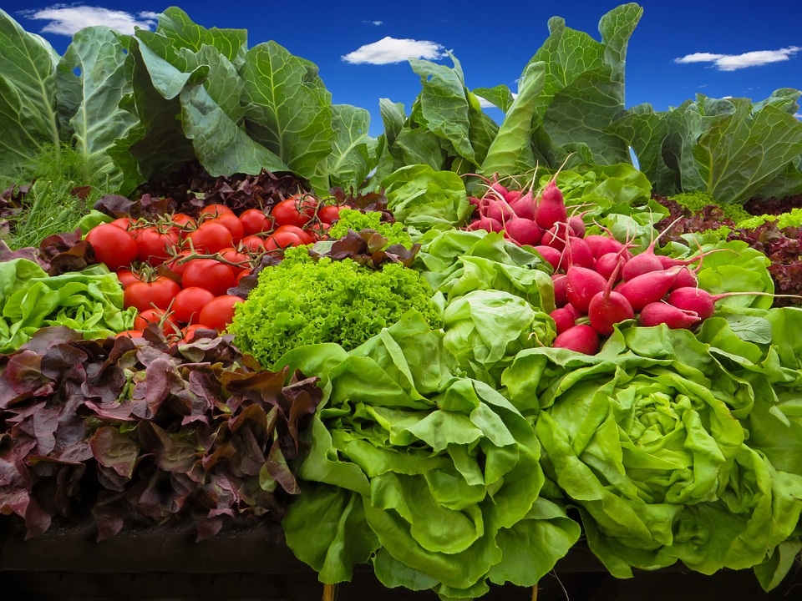

SHAC’s Guide to Filling your Belly with Yummy and Affordable Food

while working your tail off as an OHSU student
2018

http://www.ohsu.edu/xd/education/student-services/joseph-trainer-health-wellness-center/
Why this resource guide?
Portland is the hub of all things food but often at a premium. Having access to nutritious and affordable food is incredibly important. As important as nailing that project or having a breakthrough after a tough study period. It is the fuel that allows us to do the amazing work we do here at OHSU. The students on OHSU’s Student Health Advisory Committee (SHAC) recognize that there can be many barriers to finding nutritious food that won’t break the bank. As representatives of the student voice, they have put together this guide as an entry point for identifying places to purchase food in and around campus, areas to store and heat food, and referral information on available community resources. Have suggestions on how to improve this guide? Send an email to askJBThealth@ohsu.edu.
OHSU Cafes on Campus:
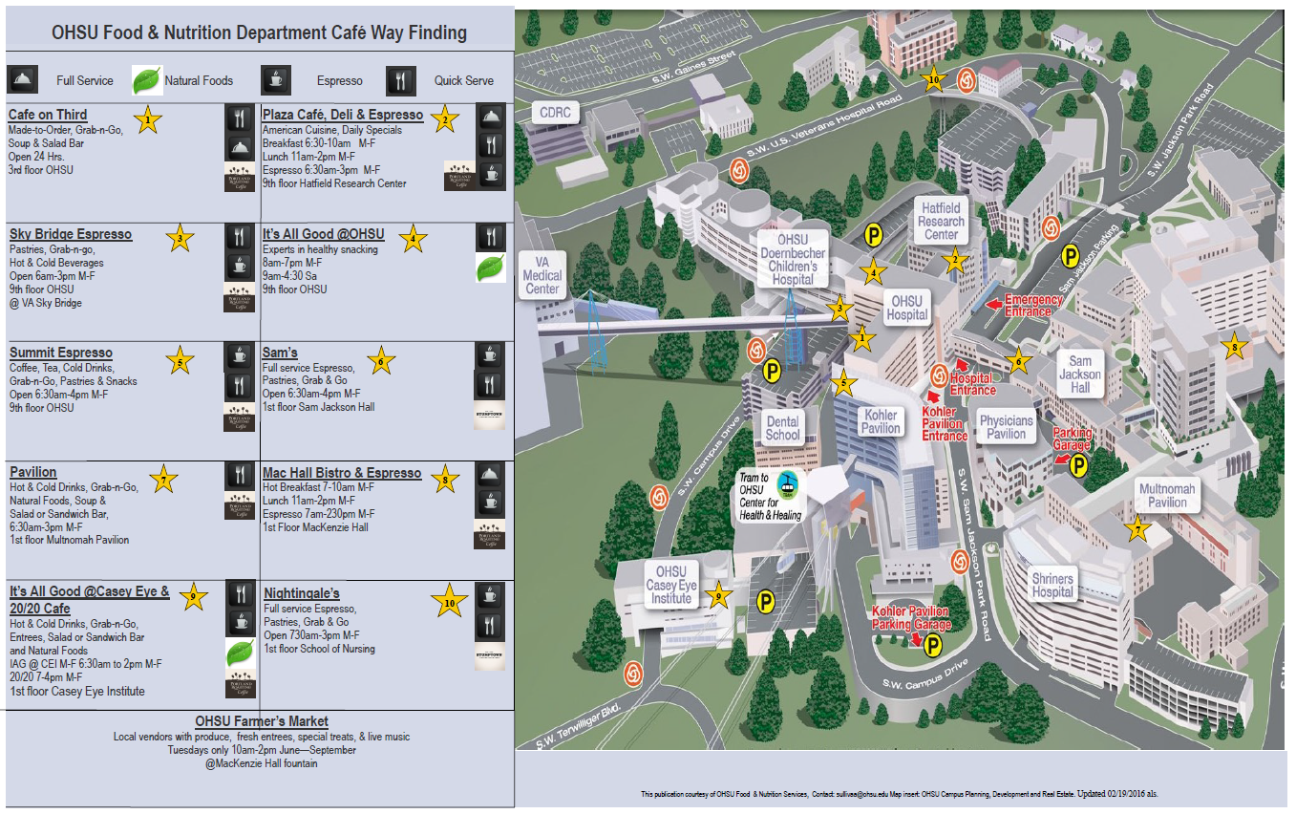

Hospital Food? Yes! Best Kept Secrets on Campus
Shriners Hospital for Children Cafeteria
This is a great spot for low-cost, nutritious food. https://www.shrinershospitalsforchildren.org/Locations/portland/Patients-and-Families/Food-Services
Veterans Administration Hospital Cafeteria
Another good spot for low cost food.
https://www.portland.va.gov/visitors/canteen.asp
Café on Third, OHSU Cafeteria
A $5 lunch option available every day.

Restaurants On or Near Campus
Marquam Hill
OHSU Farmer’s Market is open June-September, 10am-2pm in the space outside MacKenzie Hall.
South Waterfront
Check out the South Waterfront Community Relations retail page for information about restaurants on the South Waterfront. http://www.southwaterfront.com/
South Waterfront Farmers Market is open June-October, 2pm-7pm in the Elizabeth Caruthers Park.

Vending Machines
Marquam Hill:
There are three Canteen machines on campus that offer traditional snacks as well healthful and organic snacks located in Doernbecher Children’s Hospital, Richard Jones Hall and Vollum Institute. Read more here: https://www.ohsu.edu/xd/education/student-services/student-life/upload/Vending-Machine-Website-Info-2.pdf
Other OHSU locations:
Please see OHSU’s vending machine location document for additional information about other vending machine locations. https://www.ohsu.edu/xd/education/student-services/student-life/upload/LIST-OF-VENDING-MACHINES.pdf
VA:
There are also vending machines with healthier options on the 2nd floor, next to the sky bridge for cold beverages and snacks as well as in Building 100, Room 1D-141 (outside the Food Court) available 24 hours-a-day with hot and cold beverages, food items, snacks, water.

Microwaves and Refrigerator Locations:
Marquam Hill:

School of Nursing Student Lounge
This is a coded space located on the South Wing 3rd floor, around the corner from classrooms 358/364. The Student Lounge has a fridge, microwaves, kitchen sink, and vending machines with healthier choices for snacks. The vending machine take credit cards, cash, and coins. Please contact your SON administrator for the code.

Veterans Administration Hospital
There is a microwave available 24 hours-a-day in Building 100, Room 1D-141 (outside the Food Court).

The Student Center
There is a microwave in the Nucleus lounge. Open 6am-10pm.

The Old Synapse Café
The café is closed but there is a microwave still there.

Sam Jackson Hall
This space is intended to serve medical students and SON midwifery students on call during their clinical experience curriculum. Located in the 4200 Medical Student Call Room and has one refrigerator and one microwave.

South Waterfront:
CLSB Student Lounge
This is a coded space open to all OHSU students and has microwaves, refrigerators, and coffee makers.

Where Else To Find Good Deals
Elephants Deli at CLSB
Sells their hot food and expiring sandwiches at 50% off after 6pm each evening.

Portland Area Grocery Stores
Here is the lowdown on local area grocery stores: (ranked $-$$$$)
- Fred Meyer’s - locals call it Freddy’s (in other cities: Kroger, Ralph’s, Fry’s, King Soopers) - has everything food wise you could ever need ($)
- WinCo - cheap and great for dried/bulk goods and stocking up (s)
- Safeway/Albertsons - Safeway downtown is convenient from the South Waterfront ($)
- Trader Joe’s - great pre-made lunches/dinners both frozen and fresh, great wine ($$)
- Folks Urban Market (right by the streetcar) - it’s your typical grocery store ($$)
- Zupan’s - there are a couple downtown ($$$)
- New Seasons - very similar to Whole Foods but local ($$$)
- Whole Foods – many organic choices ($$$)
Fresh Produce Delivery That Won’t Break The Bank
Imperfect Produce. Fruits and veggies for 30-50% less than grocery stores, delivered to your door. https://www.imperfectproduce.com/
Want To Cook At Home? Try these recipes for good food at a good price.
Leanne Brown’s Good and Cheap. Eat Well on $4/Day. Download the PDF for free. https://www.leannebrown.com/cookbooks/
Budget Healthy Cooking:
https://www.oregonfoodbank.org/ourwork/programs/education/nutrition-cooking/
Oregon State University Food Hero:
http://studentlife.oregonstate.edu/hsrc/food-security/events-free-food

What Else Is Available Around Town?
Being a student can often mean stretching an already tight budget. We also recognize that not getting nutritional needs met can have a significant impact on academic achievement. There are local, community resources that you and your family may be eligible for. We encourage you to check out these resources.
Oregon Food Bank
Check out the Food Finder app on their website: A searchable list of agencies providing free food, meals and groceries, food pantries and food services. They also offer free gardening lessons!
https://www.oregonfoodbank.org/find-help/find-food/
Portland State University Harvest Share
Harvest Share is a free market that brings FREE fresh vegetables and fruit to the SW Park Blocks the second Monday of the month at noon, rain or shine, first-come/first served. This is open to the greater PSU community which includes OHSU students. https://www.pdx.edu/student-access-center/harvest-share-free-market
Additional resources for joint PSU-OHSU students: https://www.pdx.edu/student-access-center/
211 Info: Food Assistance.
Dial 211, text your zip code to 898211 or email help@211info.org to find out more information about food programs in your neighborhood http://211info.org/food/
WIC: Women, Infants, and Children
Check their website for a pre-screening tool to find out if you may be eligible. http://www.oregon.gov/oha/ph/healthypeoplefamilies/wic/Pages/index.aspx
Oregon Department of Human Services:
http://www.oregon.gov/DHS/Pages/index.aspx
The Supplemental Nutrition Assistance Program (SNAP). Check out the eligibility tool to find out if you may qualify. http://www.oregon.gov/DHS/ASSISTANCE/FOOD-BENEFITS/Pages/Eligibility-Apply.aspx
There is a separate list of criteria for students of higher education seeking SNAP benefits. http://www.oregon.gov/DHS/ASSISTANCE/FOOD-BENEFITS/Pages/Student-Eligibility.aspx
http://www.clasp.org/resources-and-publications/publication-1/SNAP-for-College-Students-1.pdf
Oregon Farmers Markets match SNAP benefits. Check to see if your neighborhood farmers market matches your SNAP benefit. https://oregonhunger.org/farmers-markets-snap
Multnomah County Child Hunger Coalition
Check out their interactive map of food access-related resources including information about community gardens and farmers markets. http://multco.maps.arcgis.com/apps/webappviewer/index.html?id=6f41add90d0e42b8a6d7f85a1abc0d66
The Oregon Summer Food Service Program (SFSP)
SFSP provides nutritious meals to children during the summer. Children who normally receive free or reduced price meals when school is in session are eligible. These meals are often linked to free, fun, outdoor summer activities. https://www.benefits.gov/benefits/benefit-details/1748
Benefits.gov
A central location to help you determine eligibility for government benefits including health insurance, energy assistance, childcare assistance, as well as many other local resources.
OHSU Student Debt Counseling and Management
There are resources at OHSU to assist you in better understanding your particular financial challenges and to help with educational debt planning and budgeting. http://www.ohsu.edu/xd/education/student-services/financial-aid/student-debt-counseling/index.cfm

